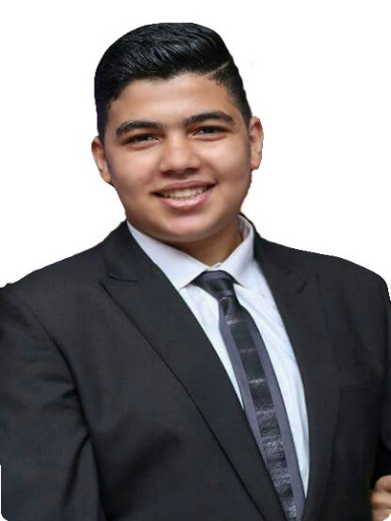**C.V**

**Khaled Samir Hassan**

Address: 115 Ahmed Oraby St., Ain Shams, Cairo, Egypt

Mobile: 01110938304/01202903276

Email: khaledshassan38@gmail.com

**Personal data**

* Date of Birth: 10-11-1997
* Place of birth: Cairo
* Marital Status: Single
* Nationality: Egyptian
* Gender: male
* Religion: Muslim

**Education**

 

* High School : Om Kalthom Experimental Language School
* Third year atFaculty of Computers and information, Cairo University**.**
* Major (CS)
* GPA 2.08

**Language**

* Arabic (mother tongue)
* English (Excellent)

**Computer skills**

* Microsoft office
* PC maintenance
* Adobe Program
  + Photoshop (Very good)
  + Illustrator (Good)
  + Premiere (Good)

**Computer language skills**

* C++
* HTML
* CSS
* PHP (Beginner)
* MySQL
* Robotics (Arduino)
* Java
* Python (Beginner)

**Certificate**

* Junior developer in computer programming (4 Levels) – Microsoft
* CCNA